*Prayer*

God of infinite goodness and eternal wisdom,   
I implore you for our brothers and sisters who suffer   
in hospital beds, alone and abandoned.   
We pray for their families, especially those who weep at this moment   
unable to say goodbye to their loved one.

We pray for leaders of the World Health Organisation, national and local leaders. Look with kindness on our elderly, our children and   
especially those who suffer from mental illness.   
Lord, console mothers and fathers of families   
who don’t have food to give their children.

Lord, give us courage and perseverance to combat fear   
and strength to sustain the most vulnerable.   
May our prayer reach and sustain those who most suffer at this time.

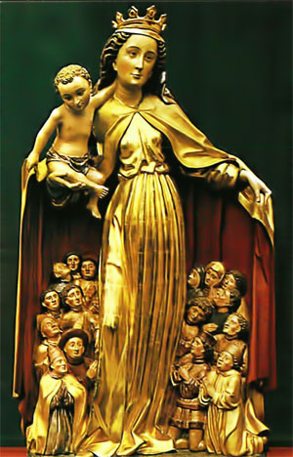We pray,   
through the intercession of our founders   
Jean-Claude Colin and Jeanne-Marie Chavoin   
and we ask the protection of   
Mary Mother of Mercy,   
for all those affected by Covid-19,   
that they may feel their Mother’s consolation.

***In your tenderness come quickly to meet us  
for we are utterly weakened.   
Help us, God our Saviour,   
for the glory of your name.*** *(Ps 79:8–9)*

Amen.