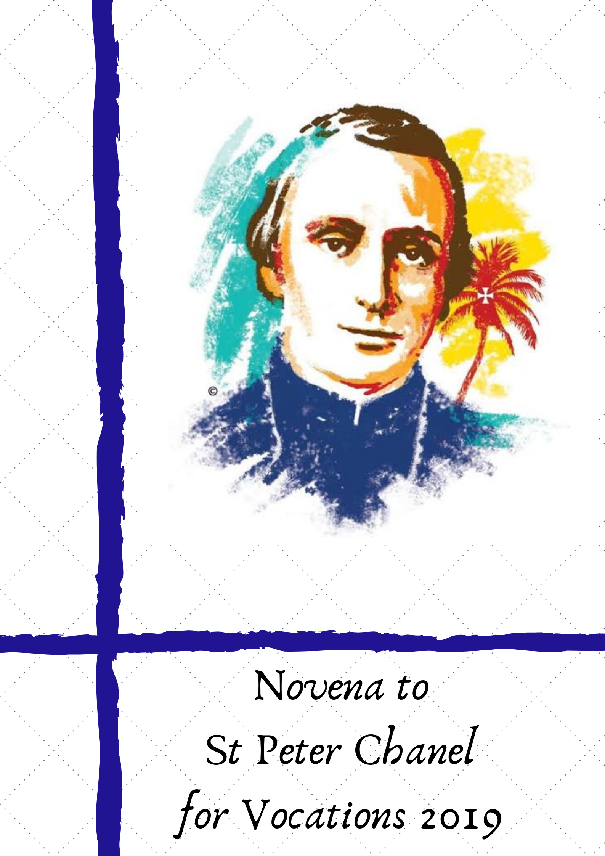

It is a Marist tradition that the nine days leading up to the Feast of St Peter Chanel are dedicated to prayer for vocations to the priesthood and the religious life.

The prayers and reflections in this booklet are taken from

• “***The courage to take a risk for God’s promise*** “ Message of Pope Francis for World Day of Prayer for Vocations 2019

•  Ever Your Poor Brother Peter Chanel :Surviving Letters and Futuna Journal. Presented by WJ Stuart & A Ward. APM. Rome. 1991

 The prayers and reflections in this booklet can be used individually, in a group setting or as part of community prayer.

**PRAYER FOR VOCATIONS**

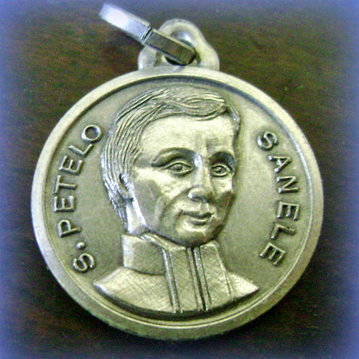***May the Virgin Mary, Mother of the Church,***

***watch over each tiny seed of a vocation***

***in the hearts of those whom the Lord calls***

***to follow him more closely.***

***May she help it grow into a mature tree,***

***bearing much good fruit for the Church***

***and for all humanity.***

***St Peter Chanel,***

***you left your homeland to proclaim Jesus.***

***Like you, may our lives bring forth***

***a witness of joyful commitment to Jesus.***

***Call forth from our midst***

***many workers for the Gospel,***

***so God’s love may reach the ends of the earth.***

***We ask this prayer through Jesus our brother. Amen.***

**DAY ONE: April 19**

*23 July 1837. During the voyage from France, Peter wrote to his mother about the death of Fr Bret at sea.*

‘Fr Bret , whom you have met at home, had shown himself to be full of care and attention for those who had been unwell. After our stopover at Tenerife, he came aboard with a headache which, instead of getting better at sea, grew steadily worse. ….. I was his room-mate and left him as little as possible, so his death came as a thunderbolt. … However I came to realise that the lot of my dear confrere should excite me to envy not tears. In fact all the consolations of our holy religion were given to him… Fr Bret caused us great distress on the Monday morning when he told us that his life was drawing to a close…. Peacefully he fell asleep in the Lord. …. Rejoice Mother dear if you should ever hear that I have died such an edifying death.’ (page 130)

**MESSAGE OF POPE FRANCIS FOR WORLD DAY OF PRAYER FOR VOCATIONS 2019**

*Dear Brothers and Sisters,*

After the lively and fruitful experience of the Synod devoted to young people last October, we recently celebrated the Thirty-fourth World Youth Day in Panama City.  These two great events allowed the Church to be attentive both to the voice of the Spirit and to the life of young men and women, their questions and concerns, their problems and their hopes.

Building on what I shared with the young people in Panama, I would like to reflect, on this World Day of Prayer for Vocations, on how the Lord’s call makes us *bearers of a promise* and, at the same time, asks of us the *courage to take a risk*, with him and for him.  I will do this by reflecting briefly with you on these two aspects – promise and risk – as they appear in the Gospel account of the calling of the first disciples by the sea of Galilee (*Mk* 1:16-20).

.

**DAY TWO : April 20**

*27 November 1839. Futuna. Letter from Fr Chanel to Fr Vuillod, a friend and seminary professor in France.*

‘I delight in seeing the ranks of the clergy increasing day by day. The premature death of Fr Bret, will not, I hope, put off the young priests who are contemplating coming here to join us. Missionaries die, but a mission must not die.’ (page219)

**MESSAGE OF POPE FRANCIS FOR WORLD DAY OF PRAYER FOR VOCATIONS 2019**

Two pairs of brothers – Simon and Andrew, and James and John – are going about their daily tasks as fishermen.  In this demanding work, they had learned the laws of nature, yet at times, when the winds were adverse and waves shook their boats, they had to defy the elements.  On some days, the catch of fish amply repaid their efforts, but on others, an entire night’s work was not sufficient to fill their nets, and they had to return to shore weary and disappointed.

Much of life is like that.  Each of us tries to realize his or her deepest desires; we engage in activities that we hope will prove enriching, and we put out on a “sea” of possibilities in the hope of steering the right course, one that will satisfy our thirst for happiness.  Sometimes we enjoy a good catch, while at others, we need courage to keep our boat from being tossed by the waves, or we are frustrated at seeing our nets come up empty.

**DAY THREE: April 21**

*2 May 1838. Futuna. Letter from Fr Chanel to Fr Bataillon in Wallis.*

*On arrival by boat from Uvea, Chanel witnessed a killing between locals, there in the surf.*

'We dropped anchor at nine on Friday evening.... The attacker (in the water), instead of embracing his victim, grabbed him firmly by the arm, and waited for reinforcements. One of these seized the victim’s other arm. Then a third man coolly speared him several times in the belly. He was finally struck a blow to the forehead with an axe and let to drop. In spite of the heavy loss of blood, this mortally wounded man kept on swimming for all he was worth, but since he was swimming out backwards, he headed away from the shore, and was lost in the waves.' (page 158)

**MESSAGE OF POPE FRANCIS FOR WORLD DAY OF PRAYER FOR VOCATIONS 2019**

As with every call, the Gospel speaks of an encounter.  Jesus walks by, sees those fishermen, and walks up to them…  The same thing happened when we met the person we wanted to marry, or when we first felt the attraction of a life of consecration: we were surprised by an encounter, and at that moment we glimpsed the promise of a joy capable of bringing fulfilment to our lives.  That day, by the sea of Galilee, Jesus drew near to those fishermen, breaking through the “paralysis of routine” ([*Homily for the XXII World Day for Consecrated Life*, 2 February 2018](javascript:disclaimer(%22http://w2.vatican.va/content/francesco/en/homilies/2018/documents/papa-francesco_20180202_omelia-vita-consacrata.html%22);)).  And he immediately made them a promise: “I will make you fishers of men” (*Mk*1:17).

The Lord’s call is not an intrusion of God in our freedom; it is not a “cage” or a burden to be borne.  On the contrary, it is the loving initiative whereby God encounters us and invites us to be part of a great undertaking.  He opens before our eyes the horizon of a greater sea and an abundant catch.

**DAY FOUR: April 22**

*22 May 1838 Futuna. Letter of Fr Chanel to Fr Bataillon in neighbouring Wallis. At the beginning, Marie Nizier and Chanel lived in the king’s house. They had little privacy and many difficulties with the new language.*

'Brother Marie Nizier and I are still living in a corner of the king's house. The numerous wedding feasts have prevented his Majesty from getting on with building our house. I have no idea how long this provisional arrangement will last. The crowd is still all over us and we can do very little work. I am forever confusing a large number of words - despite your efforts in teaching me. The principal reason for my confusion is that there are so many letter s's among the words. ' (page 164)

**MESSAGE OF POPE FRANCIS FOR WORLD DAY OF PRAYER FOR VOCATIONS 2019**

Embracing this promise naturally demands the courage to risk making a decision.  The first disciples, called by Jesus to be part of something greater, “immediately left their nets and followed him” (*Mk* 1:18).  Responding to the Lord’s call involves putting ourselves on the line and facing a great challenge.  It means being ready to leave behind whatever would keep us tied to our little boat and prevent us from making a definitive choice.  We are called to be bold and decisive in seeking God’s plan for our lives.  Gazing out at the vast “ocean” of vocation, we cannot remain content to repair our nets on the boat that gives us security, but must trust instead in the Lord’s promise.

**DAY FIVE: April 23**

*31 October 1839. Futuna. Letter of Fr Chanel to Bishop Devie in Belley, France. A long running feud made violent death a part of life for Chanel and Marie Nizier on the island.*

‘The battle lasted but a few minutes… The king sent me to render assistance to the wounded among whom he himself numbered. …. We found… only the wounded and the dead, with a few weeping women covering themselves with the blood flowing from the wounds of their dear ones.’ (page 214)

**MESSAGE OF POPE FRANCIS FOR WORLD DAY OF PRAYER FOR VOCATIONS 2019**

I think primarily of the call to the Christian life which all of us received at Baptism.  It teaches us that our life is not a fluke but rather a gift: that of being God’s beloved children, gathered in the great family of the Church.  It is precisely in the ecclesial community that the Christian life is born and develops, especially through the liturgy.  The liturgy introduces us to God’s word and the grace of the sacraments; from an early age, we are taught the art of prayer and fraternal sharing.  In the end, the Church is our mother because she brings us to new life and leads us to Christ.  So we must love her, even when we see her face marred by human frailty and sin, and we must help to make her ever more beautiful and radiant, so that she can bear witness to God’s love in the world.

**DAY SIX: April 24**

*12 October 1839. Letter of Fr Chanel to Fr Antoine Seon – a missioner at Belley who had already applied for the missions.*

‘It is only prayer that can give life to our ministry to the poor natives. Without its help, all our efforts are sterile and in vain... It is now twenty-three months since I came among them, but only recently have I been able to speak their language at all properly.’ (page206)

**MESSAGE OF POPE FRANCIS FOR WORLD DAY OF PRAYER FOR VOCATIONS 2019**

The Christian life thus finds expression in those decisions that, while giving a precise direction to our personal journey, also contribute to the growth of God’s kingdom in our world.  I think of the decision to marry in Christ and to form a family, as well as all those other vocations associated with work and professional life, with the commitment to charity and solidarity, with social and political responsibilities, and so forth.  These vocations make us bearers of a promise of goodness, love and justice, not only for ourselves but also for our societies and cultures, which need courageous Christians and authentic witnesses of the kingdom of God.

**DAY SEVEN: April 25**

*1839. Fr Chanel received news of the death of his loved sister Francoise, a religious (Sister Saint Dominique) who was particularly dear to him.*

*Writing to fellow missionary Br Luzy who also knew her:*

‘My sister, Sister Saint-Dominique tried to steal a march on me getting to heaven first. She died around Easter 1838.’ (page 175)

*And to Fr Colin*: ‘I am so convinced that the good Lord has been merciful to her… I could not weep for her.’ (page 172)

*And to Fr Bolliat*: ‘I cannot thank you enough for your many kindnesses to my good mother. They greatly sustain her faith and confidence in God and make the awareness of my absence less bitter for her.’ (page223)

**MESSAGE OF POPE FRANCIS FOR WORLD DAY OF PRAYER FOR VOCATIONS 2019**

In encountering the Lord, some may feel the attraction of a call to the consecrated life or to the ordained priesthood.  It is a discovery that can excite and at the same time frighten us, since we feel called to become “fishers of men” in the barque of the Church by giving totally of ourselves in commitment to faithful service of the Gospel and our brothers and sisters.  Such a decision carries the risk of leaving everything behind to follow the Lord, to devote ourselves completely to him, and to share in his work.  Many kinds of interior resistance can stand in the way of making this decision, especially in highly secularized contexts where there no longer seems to be a place for God and for the Gospel.  Places where it is easy to grow discouraged and fall into the “weariness of hope” ([*Homily at Mass with Priests, Consecrated Persons and Lay Movements*, Panama, 26 January 2019](javascript:disclaimer(%22http://w2.vatican.va/content/francesco/en/homilies/2019/documents/papa-francesco_20190126_omelia-cattedrale-panama.html%22);)).

And yet, there can be no greater joy than to risk one’s life for the Lord!  I would like to say this especially to you, the young.  Do not be deaf to the Lord’s call.  If he calls you to follow this path, do not pull your oars into the boat, but trust him.  Do not yield to fear, which paralyzes us before the great heights to which the Lord points us.  Always remember that to those who leave their nets and boat behind, and follow him, the Lord promises the joy of a new life that can fill our hearts and enliven our journey.

**DAY EIGHT: April 26**

*16 May 1839. Futuna. Letter of Fr Chanel to Fr Jean-Claude Colin.*

'The island is not yet Christian; apart from my lack of zeal, there are a thousand and one fears and prejudices to be dispelled.... The king and most of the chiefs are reputed to have gods that descend on them... inspiring fear. Twenty baptisms, four of which were adults and the rest children, and all in danger of death, make up the entire harvest I have reaped in eighteen months.' (p171)

**MESSAGE OF POPE FRANCIS FOR WORLD DAY OF PRAYER FOR VOCATIONS 2019**

Dear friends, it is not always easy to discern our vocation and to steer our life in the right direction.  For this reason, there needs to be a renewed commitment on the part of the whole Church – priests, religious, pastoral workers and educators – to provide young people in particular with opportunities for listening and discernment.  There is a need for a youth ministry and a vocational promotion that can open the way to discovering God’s plan, above all through prayer, meditation on God’s word, eucharistic adoration and spiritual accompaniment.

**DAY NINE: April 27**

*16 May 1840. Futuna. Fr Chanel to Fr Colin.*

‘Soon death will come to decimate our still feeble ranks. Will the missions be condemned to die with their missionaries? Must brambles and thorns spring up in the different parts of the field of the Lord…. for lack of zealous labourers to take over from us? …Very Reverend Father, tell the students at Belley… what affection I still have for them…

**MESSAGE OF POPE FRANCIS FOR WORLD DAY OF PRAYER FOR VOCATIONS 2019**

As was made clear several times during the World Youth Day in Panama, we should always look to Mary.  Also in the story of this young woman, vocation was both a promise and a risk.  Her mission was not easy, yet she did not allow fear to prevail.  “It was the ‘yes’ of someone prepared to be committed, someone willing to take a risk, ready to stake everything she had, with no more security than the certainty of knowing that she was the bearer of a promise.  I ask each one of you: Do you see yourselves as bearers of a promise?  What promise do I bear within my heart to take forward?  Mary’s would undoubtedly be a difficult mission, but the challenges that lay ahead were no reason to say ‘no’.  Things would get complicated, of course, but not in the same way as happens when cowardice paralyzes us because things are not clear or sure in advance” ([*Vigil with Young People*, Panama, 26 January 2019](javascript:disclaimer(%22http://w2.vatican.va/content/francesco/en/speeches/2019/january/documents/papa-francesco_20190126_panama-veglia-giovani.html%22);)).

On this World Day of Prayer for Vocations, let us join in prayer and ask the Lord to help us discover his plan of love for our lives, and to grant us the courage to walk in the path that, from the beginning, he has chosen for each of us.

*From the Vatican, 31 January 2019  
Memorial of Saint John Bosco*

**FRANCIS**