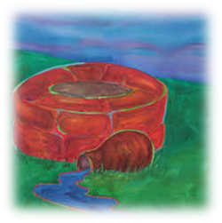

**Fiji Report – Mariana Tevurega**

Pacific Church leaders gathered for a workshop on ‘Seabed Mining’ at the Pacific Theological College, Suva, 3rd – 8th April 2017.

Aware of the destruction caused by this form of mining, they have published the following statement:

1. 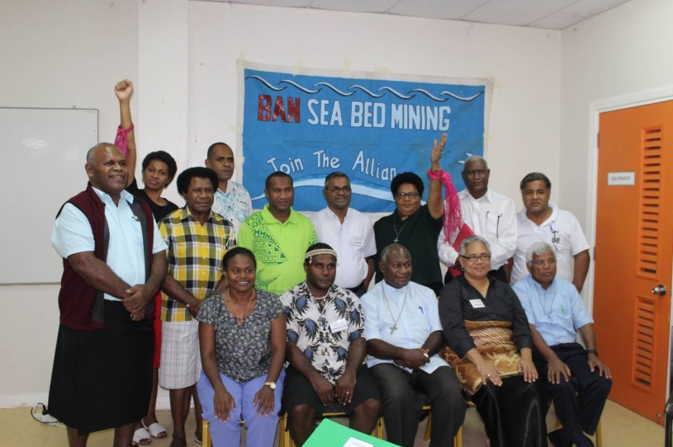We call on the PNG Government and other Pacific countries to put a stop to testing of Seabed technology on PNG Land or Seas.
2. We call on the civil society to stand with the churches and the Alliance of Solwara Warriors to say “NO” to any development regarding Seabed Mining in their area.
3. We call on the Governments and the people of the Pacific to stand together to preserve our common home for the unborn and the future generations.
4. Our Mandate is from God: “God put man in the Garden of Eden to dress it and keep it” (Gen 2:15). The world was here before we came on the scene. Who are we to destroy it?
5. 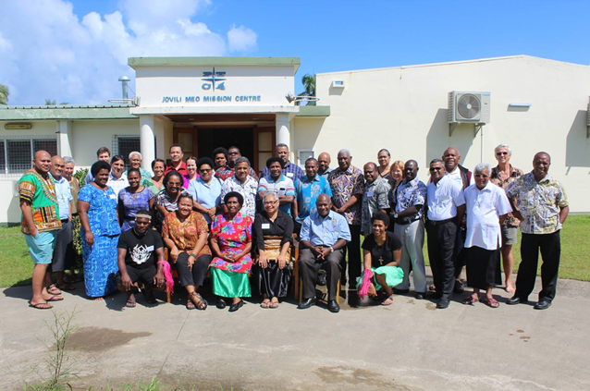We call on all the people and the governments of the Pacific to stand together in solidarity to “Ban Seabed Mining” in PNG and the Pacific.

Church leaders joining forces with Solwara Alliance

in its stand against deep seabed mining

in the beautiful Pacific Ocean.

Above Mariana wears the coloured arm band   
to highlight identification   
 with Solwara Alliance.

***Suore Mariste, Roma – 2017/1***



Justice and Peace

across our Units

**Even as the quality of available water is constantly diminishing, in some places there is a growing tendency, despite its scarcity, to privatize this resource, turning it into a commodity subject to the laws of the market. Yet *access to safe drinkable water is a basic and universal human right, since it is essential to human survival and, as such, is a condition for the exercise of other human rights*. Our world has a grave social debt towards the poor who lack access to drinking water, because they are denied the right to a life consistent with their inalienable dignity.** Laudato Si 30

With this edition of Connecting Links comes one further document:

Prayer around Goal 6 of the Sustainable Development Goals – Water

This is an important focus for the coalition of 21 congregations forming UNANIMA.

* Let us **reflect** on what the UN is promoting with Goal 6:

**‘ to ensure availability and sustainable management of water and sanitation for all’**

* Let us **pray**
* Let us **give thanks** for women like Meera Karunananthan, UNANIMA’s 2016 Woman of Courage, who led a two year global coalition for the human right of water to be named in the Sustainable Development Goals.



Meera Karunananthan

* Let us **access** the many excellent resources available to us – in our various languages - at <http://www.blueplanetproject.net/>
* Let us **support** **Water With Blessings!**  
  This group, with UNANIMA’s support and encouragement,  **empowers, equips,**and

**entrusts MOTHERS**as agents of clean water and compassion for their children and their communities. [**info@waterwithblessings.org**](mailto:info@waterwithblessings.org)

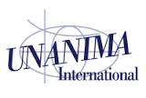

**Meeting March 2017**

A definite highpoint of our meeting was the animated input from Meera Karunananthan, UNANIMA’s 2016 Woman of Courage. Born in Sri Lanka, educated in Quebec, Canada, Meera’s passion is water! She has spent much of her young life organizing public-access-to-water campaigns and opposition to privatization of water and is partly responsible for Goal 6 of the Sustainable Development Goals – access to clean water and sanitation.

She laughingly shared the story of how at one point the chair of a committee at the UN snapped,

“We’ve heard enough about the right to water!”

Meera added, “At that point we knew we were doing

a good job!”

Water is an issue that touches people from all communities and all walks of life - a precious gift, not a commodity! Using a quotation from Gandhi**: “Earth provides enough to satisfy every man’s need but not his greed”** Meera reminded us that we are living within a system that does not distribute equally and equably.

One of the biggest problems of capitalism is its insatiable need for growth and lack of water is seen as one of the biggest threats to this. Therefore, some of the biggest companies in the world, encouraged by the World Bank, have formed an alliance.

These companies include Coca Cola, Pepsi, Nestlé and some of the large mining companies. They are writing their own water policy, co-opting environmental language and hijacking phrases like ‘valuing water’. But ‘valuing’ as they use the word does not mean safeguarding, protecting, recognizing its true or inherent worth, rather they come at it from a market-based perspective and mean pricing, trading water allocations, buying and selling water rights.

**Her challenges to each of us**….

* To remember we are the guardians of the human right to water. The **‘Blue Communities Project’** is aimed at getting local communities and authorities to recognize this right.
* Where water is safe to use, do not buy bottled water.
* At local level form part of the resistance to privatizing water supplies and sanitation
* ****On a wider level, question and challenge the extractive based model of growth.