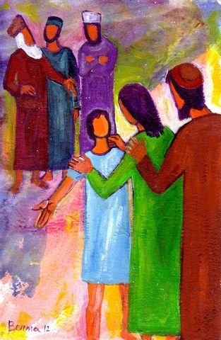

***1817 – 2017 Celebrations***

***Mary, Jeanne-Marie and each of us***

***Three days*** later Mary and Joseph found Jesus in the Temple… they were upset and hurt.

His mother said, “Young man, why have you done this to us? Your father and I have been half out of our minds looking for you.”

**His mother held these things dearly,**

**deep within herself.**  Lk 2: 46-48

***4. Jesus,***

***the Temple,******and Nazareth***

***Losing sight of Jesus****…* Jeanne Marie Chavoin: “When we lose the spirit of prayer we go astray”. **RMJ 141.1**

***An invitation to return home with Jesus****…* In always directing your first thought to Him who wills or allows everything, you cannot lose the presence of God. **CMJ 86.2**

***Pondering*** *…* Do you not realise that you are a Temple of God with the Spirit of God living in you? …God’s Temple is holy, and you are that temple. **1 Cor 3: 16-17**

Neuroscience now tells us that fear, negativity, and hatred stick like Velcro to the nerves, while positivity, gratitude, and appreciation slide away like Teflon from those same nerves – until we savour them, or choose them, for a minimum of a conscious fifteen seconds! Only then do they imprint! … The positive, loving, non-argumentative savouring of the moment is called contemplation.

**The Divine Dance, Richard Rohr P. 116**

A Marist sister's sole desire should be to resemble the little family…

Last Words of Mother St Joseph *on the eve of her death*…. **RMJ Doc 108.2**

**What is my sole desire?**

**How would I describe it? How do I live it?**