**1817 – 2017 Celebrations**

**Mary, Jeanne-Marie and each of us**

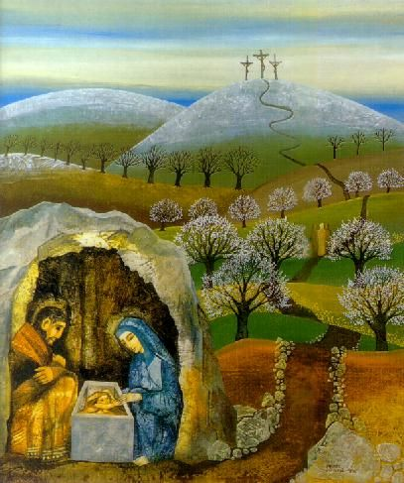

1. ***A Time To Be Born…***

The time came for her to give birth. She gave birth to a son, her firstborn. She wrapped him in a blanket and laid him in a manger, because there was no room in the hostel. Lk 2: 6-7 (MSG)

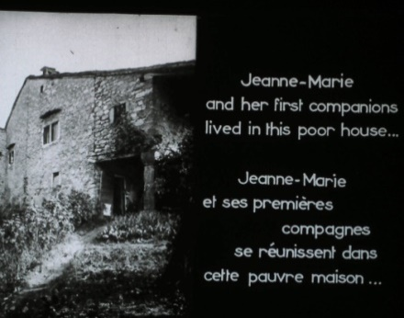

**In 1817**

**a letter from Pierre Colin arrives from Cerdon…**

**an invitation…**

**and a beginning.**

(Filmstrip Monique Biraud 1956)

***Jeanne-Marie***

Refusing all Mgr Devie’s attempts to have them join other communities, Jeanne - Marie spoke out boldly. “My Lord, there are two of us…we left home and family to start the Society of Mary.”

**RMJ 101, 7**

One cannot think without being deeply moved of all they had to suffer in their new surroundings, housed in a draughty little that­ched cottage, the approach to which was difficult and wild, dirty and very damp, with no heating but what came from a stable below their room, where there was a horse for whose benefit all holes had been carefully stuffed up.In the depth of winter they were without fire-wood or provisions,but they were always light-hearted, never uttering the least complaint, with no regret for the comfort they had left behind. They did not even think of letting their people know how they were placed; these would certainly have hastened to pro­vide abundantly for their needs. One of them told me one day that it was impossible to understand what joy they experienced in that little thatched cottage. **RMJ 162, 9-10**

**Did you have to overcome obstacles on leaving home? How did you feel?**

**Think back to the beginnings of your unit…**

**to recent experiences of hardship, maybe due to natural disasters…**

**to challenging times.**

**What do you think Jeanne Marie might say to us today?**