**Fourvière Novena: Day 1 – 14 July 2016**

1. A reading from Pope Francis’ ***Easter Urbi et Orbi message*,** March 31, 2013

God’s mercy can make even the driest land become a garden, can restore life to dry bones (cf. Ez 37: 1-14)… Let us be renewed by God’s mercy, let us be loved by Jesus, let us enable the power of his love to transform our lives too; and let us become agents of this mercy, change through which God can water the earth, pro­tect all creation and make justice and peace flourish.

1. A reading from Craig Larkin sm, ***A Certain Way***, p. 44-45

On 27th September 1846: Fr Mayet records in his Memoirs the following being said by Fr Jean-Claude Colin:

*“The Society must begin a new Church over again. I do not mean that in a literal sense, that would be blasphemy. But still, in a certain sense, yes, we must begin a new Church. The Society of Mary, like the Church, began with simple, poorly educated men; but since then the Church has developed and encompassed everything. We too must gather together everyone through the Third Order.”*

**How might we understand what this means and its deep implications?**

An entirely new civilization has arisen, deeply secularised to the point that the very existence of God and His merciful call is for many people meaningless and irrelevant. The message of the Father must be preached again in a new language, in terms of a new culture. The incarnational movement of the Church is to start again in this new civilization. She must meet this new world on its own terms. This is how we must read today the call of our Founder: “The Society must begin a new Church over again.”

New missionaries are needed, with a new approach, to manifest the mercy of the Father in such a way that it will be understood…. *Fr Jan Snijders, sm*

1. 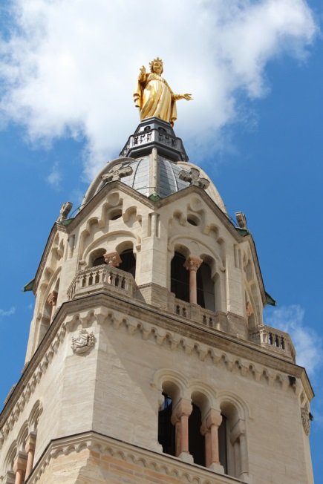Prayer

Mary, of Fourvière, show us what love is

and from where it draws its origin and its constantly renewed power.

Holy Mary, good Mother of Fourvière,

you have given the world its true light, Jesus, your Son ‐ the Son of God.

You abandoned yourself completely to God’s call

and this became a wellspring of the goodness which flows forth from him.

You inspired the first Marists

to create a Society dedicated to showing the Marian face of the Church.

Show us Jesus. Lead us to him.

Teach us to know and love him,

so that we too can become capable of true love

and be fountains of living water in the midst of a thirsting world.

Amen.