Novena for Vocations

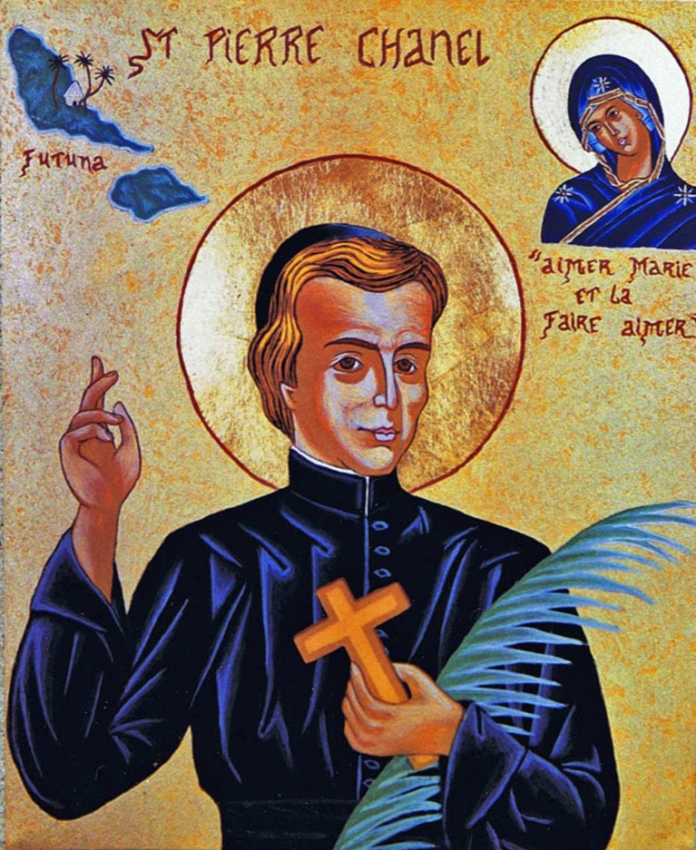

God, our Father,

you inspired St Peter Chanel

to leave his homeland

in order to proclaim   
Jesus Saviour of the world,   
to the peoples of Oceania.

Guided by your Spirit,   
who is the strength of the gentle,

he bore witness to your love,

even laying down his life.

Grant that, like him,

we may live our daily lives

in peace, in joy, and in fraternal love.

May his prayer and example

call forth from the midst of the Church   
many workers for the Gospel,   
so that your Kingdom

may reach to the ends of the earth.

We make this prayer through

Christ, our risen Lord. Amen.