***Theme 6***

**1817 – 2017 Celebrations**

**Mary, Jeanne-Marie and each of us**

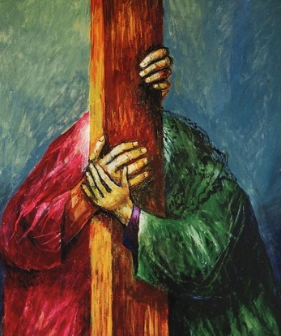

**Jesus gives his mother to the beloved disciple** ...

a moment filled with gentleness and kindness.

*Jesus, seeing his mother and the disciple whom he loved, says to her:*

*"Woman, behold your son." Then he says to the disciple: "Behold your mother. Jn 19: 26-27*

The writer adds that from that hour on, the hour of the death of Jesus, the beloved disciple takes the mother of Jesus as the Greek says, "into what belonged to him": "what was truly his own, the treasure of his heart."...

*Why have you led me,*

*faithful God,*

*down paths so strewn*

*with treacherous rocks?*

*Why seduce me,*

*numbly praying,*

*into caverns of emptiness,*

*to tread on shards of glass?*

*Why, faithful God,*

*have you brought me here*

*to stand alone*

*declaring your Name*

*in dark and empty spaces,*

*echoing back to me*

*your passionate song of love?*

*Why, faithful God,*

*have you led me dancing*

*to your door*

*without a choir or music?*

*Why, faithful God,*

*have you dared to teach me,*

*wild and unashamed,*

*such a lonely dance of love?*

*And then the answer came,*

*so subtle*

*and so thunderous,*

*"Because, beloved,*

*you were there."*

Edwina Gately, *God’s Womb* p. 156

By giving his mother as the mother of the beloved disciple Jesus is calling her to give life to the beloved disciple, to bring Jesus to birth, as it were within him, so that the disciple may dwell in Jesus and Jesus in him. And in the same gesture, the beloved disciple is being called to become Jesus for his mother, for she has only one son: Jesus. Here is the supreme unity of love and communion.

Origen, a prominent theologian, born about 80 years after the death of John the Evangelist, writes:

***Nobody can really understand this gospel***

***unless they too have reclined on the heart of Jesus***

***and received Mary as mother as the beloved disciple did.***

(Jean Vanier, *Drawn into the Mystery of Jesus through the Gospel of John*, p.324-325)

***JC Colin to JM Chavoin*:** Be courageous in the midst of your difficulties; we must give birth to the Society in pain, just as Our Blessed Mother gave birth at the foot of the Cross to us, Her adopted children. CMJ 9, 4

One day Sr Marie Jotillon had a very violent crisis…., gathering all her strength, addressed the whole community …“Behold your mother, respect her, love her, obey her as your tender mother. It was she who brought me forth to the life of grace.” RMJ 241, 96

Jeanne Marie Chavoin on the eve of her death: Speaking in a strong, clear voice after kissing a small statue of

Our Lady which she held in her hand, she said:

“Look, child, she is your Mother... RMJ 108, 2

***Ponder Edwina Gately’s poetic prayer and the passages above. What new life has grown out of moments of suffering in your Unit, your community, in your life?***