***1817 – 2017 Celebrations***

***Mary, Jeanne-Marie and each of us***

***Cana***

*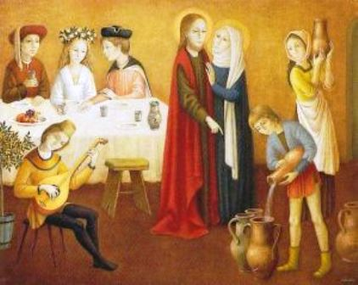5****.***

***On the third day***

*there was a wedding in Cana of Galilee,*

*and the mother of Jesus was there…*

*When the wine gave out, the mother of Jesus said to him, “They have no wine.” And Jesus said to her, “Woman, what concern is that to you and to me? My hour has not yet come.”*

***His mother said to the servants,***

***“Do whatever he tells you.” Jn 2:1-11***

***Jeanne Marie*** : A sister told her one day that she was very anxious to have a certain object, and that it would give her great pleasure. Mother answered: You don’t need it. True, the sister said, I can do without it. After a few days Mother sent the sister what she had asked for. The sister was very surprised to see Reverend Mother’s kindness, and when she tried to express her gratitude we could see that Mother experienced more pleasure in having given it than the sister in receiving it. She loved to give pleasure.

**RMJ 241.118**

At the end of the summer, Mother herself took care to check the clothing of each sister to make sure she had all she needed….**RMJ 241. 127**

**What needs do we answer that bring joy into our lives? Do we celebrate them?**

**Do we sometimes ask for help to fill the water jars?**

***Jesus* :** I have come that they may have life

and have it more abundantly. **Jn 10:10**

***We reflect*:**

**How do I transform the water of my life**

**into wine for my community?**