**1817 – 2017 Celebrations**

**Mary, Jeanne-Marie and each of us**

1. ***Urgency, Encounter, Joy …***

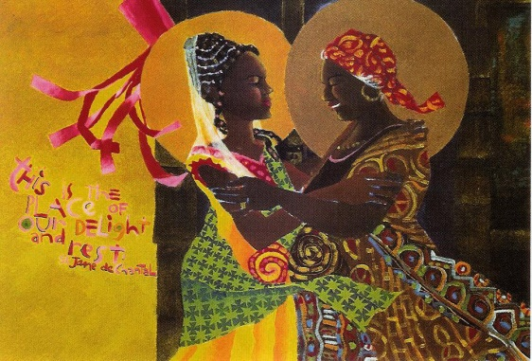***Mary*** *didn’t waste a minute. She got up and travelled to a town in Judah in the hill country, straight to Zachariah’s house, and greeted Elizabeth.*

**Elizabeth:**  *“And why am I so blessed that the mother of my Lord visits me?”*

Lk 1.39-45

***Jeanne-Marie …***

Jeanne Marie felt extreme repugnance with regard to all the propositions Cardinal Fesch had so kindly made… “Then what are you going to do?” the Cardinal said to her. “Monsignor”, she replied, “I shall remain at home till I know the will of God more clearly.” **RMJ 163, 9**

***Actively Waiting …***

She resumed her life of prayer and work but without being entirely satisfied….She was drawn with invincible force towards a state of total oblation …..She wanted to be to be a religious of the Blessed Virgin- but her aspirations encountered only silence and uncertainty. How was she to realise her dream? **RMJ 279, 14**

If she learnt that our Saviour was going to visit some poor person, she would go at her own expense and prepare the sick person to profit by this happy moment**. RMJ 162, 3**

Her fertile imagination found ways of doing good and she had her own list of the destitute and outcasts. **RMJ 279, 8**

**Go back to the beginnings of your Unit:**

**What can be said of your early Sisters and their dreams?**

**And today: Look at all the initiatives taken on by the Sisters of your Unit**

**Let us join Mary in her prayer of gratitude and joy:**

**And Mary said** : I’m bursting with God-news;  
    I’m dancing the song of my Savior God.  
God took one good look at me, and look what happened—  
    I’m the most fortunate woman on earth!  
What God has done for me will never be forgotten,  
    the God whose very name is holy, set apart from all others.

His mercy flows in wave after wave  
     on those who are in awe before him… Lk 1.39-45 (MSG)