**1817 – 2017 Celebrations**

**Mary, Jeanne-Marie and each of us**

1. *Annunciations*

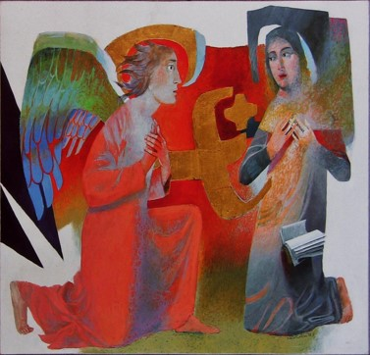

“*Mary, you have nothing to fear. God has a surprise for you…”*

***And Mary said:***

*“Yes, I see it all now: I’m the Lord’s maid, ready to serve. Let it be with me just as you say.”*

Luke 1.37-38The Message (MSG) contemporary version of the Bible

**We recall our own Annunciation moments:**

**What was my initial reaction? What or who encouraged/discouraged me?**

**What drew me onwards to the Marist way of life?**

***Jeanne-Marie Chavoin:***

In her infancy and early youth this favoured child knew nothing of the world beyond her village… **RMJ 279, 4**

One day when Jeanne-Marie had been giving M. Lefranc an account as usual, she concluded without telling him about an extraordinary grace she had been favoured with. He said to her, “But you have said nothing about what happened to you on Holy Thursday before the Blessed Sacrament.” Then, as she saw clearly that he could only have known about it by inspiration (since she had not spoken of it to anyone), she told him that it was true she had seen Our Lord in dazzling light in comparison with which all precious stones and diamonds were but dust, that her soul had received great consolation but that she had not attached any importance to it**. RMJ 163, 8**

After a very long silence, M. Lefranc suddenly replied. “God does not want you to join an existing con­gregation but one which has yet to come into existence.”**RMJ 163, 17**

We have a Mother who loves us more than all other mothers put together; that should greatly encourage us. Think then how much she loved you to have chosen you for her service amongst thousands of girls who live in the world exposed to danger. Oh my dear, how you should appreciate your vocation and thank Our Lord for all the graces He has given you… **CMJ 87, 2**

**And the graces of our calling:**

**I look back over my life in search of my initial enthusiasm…**