**Fourvière Novena: Day 2 – 15 July 2016**

1. A reading from ***The Church of Mercy*** by Pope Francis, 2014

We all carry our sins with us. But the Lord wants to hear us say to him, “Forgive me, help me to walk, change my heart!” And the Lord can change your heart. In the Church, the God we encounter is not a merciless judge but is like the Father in the Gospel parable. You may be like the son who left home, who sank to the depths, farthest from the Gospel. When you have the strength to say, “I want to come home,” you will find the door open. God will come to meet you because he is always waiting for you – God is always waiting for you. God embraces you, kisses you, and celebrates. That is how the Lord is, that is how the tenderness of our heavenly Father is. The Lord wants us to belong to a Church that knows how to open her arms and welcome everyone, that is not a house for the few, but a house for everyone, where all can be renewed, transformed, sanctified by his love – the strongest and the weakest, sinners, the indifferent, those who feel discouraged or lost.

1. 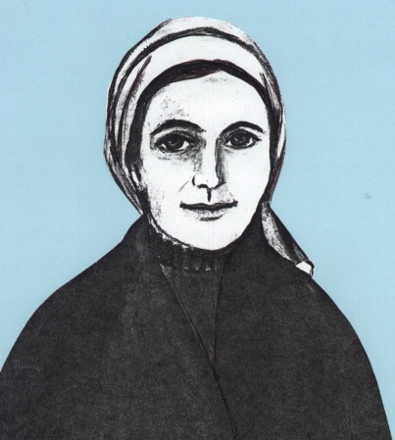A reading from ***Recollections of Mother St Joseph***, Doc. 241:96 recorded by Sr Jacques

In 1835 Sr Marie (Marie Jotillon) contracted an illness with which she suffered greatly until her death on 25 February, 1838. On one occasion when the doctor indicated that there was every chance she would die, the community gathered around her bedside. Jeanne-Marie Chavoin was holding her, when she attempted to sit up and managed to speak the following words to the assembled Sisters. Her words refer to Jeanne-Marie, Mother St Joseph:

Behold your mother, respect her, love her, obey her as your tender mother. It was she who brought me forth to the life of grace.

1. Prayer

Mary, of Fourvière, show us what love is

and from where it draws its origin and its constantly renewed power.

Holy Mary, good Mother of Fourvière,

you have given the world its true light, Jesus, your Son ‐ the Son of God.

You abandoned yourself completely to God’s call

and this became a wellspring of the goodness which flows forth from him.

You inspired the first Marists

to create a Society dedicated to showing the Marian face of the Church.

Show us Jesus. Lead us to him.

Teach us to know and love him,

so that we too can become capable of true love

and be fountains of living water in the midst of a thirsting world.

Amen.